-BRAINCHILD-

Might your child suffer from ‘summer learning loss’ this summer?

‘...the evidence of ‘summer learning loss’ is beyond dispute.... summer learning camps would help...’
‘...you are never too young to learn philosophy. Weekly philosophy sessions improve problem-solving skills, communication and confidence, and raise IQ levels...’

The Times 20th – 21st July/2011

Come to our summer learning camp at the Lordshill Community Centre opposite Sainsbury’s, where we teach philosophy for kids aged 6 - 11, ‘brain’ games like chess, sudoku, scrabble and backgammon, and have a fun sports bit in the middle! For your child it’s chat, followed by sports, followed by fun board games. For you, it’s mind-toning for your child - stopping the summer brain drain – oh, and a day off! Drinks will be provided but your child should please bring a packed lunch and snacks. The course will run every Tuesday in August, from 10am – 4pm and costs just £25 per day. Discounts are available for more than one child, and block bookings.
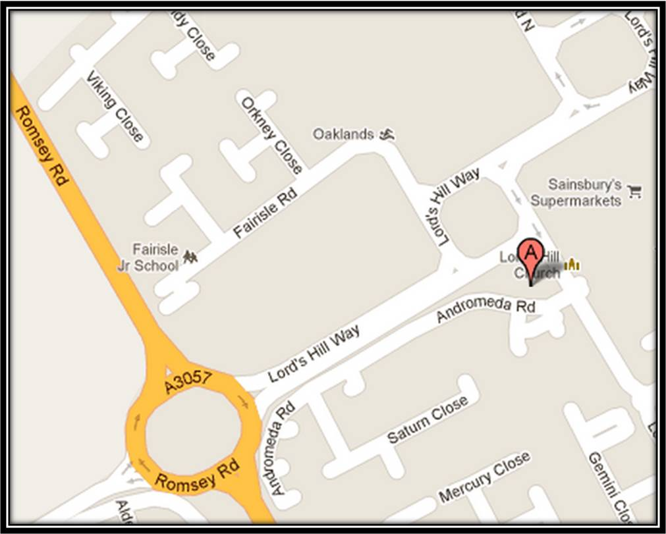

Secure, fenced site
Fully Insured
Enhanced CRB checked
For kids aged 6 - 11
Graduate tutors

Call now to reserve your place: 02380 701 802 or 0770 463 4352      

